Blackwater Medical Centre Newsletter
March 2024
Staff Update

Welcome to Dr M Ashraf MBBS MRCGP DFSRH DRCOG

Dr Ashraf finished her GP training in 2014. She has experience in a variety of medical specialities. Her specialist interests include complex care, women’s and sexual health. She enjoys doing family planning and menopausal clinics. She works to empower a holistic, pragmatic and individualised approach to General Practice and enjoys the one-to-one interaction with her patients. Outside of work, Dr Ashraf enjoys cooking, reading books, and planning the next adventure somewhere.

Farewell to Dr Richardson

We bid farewell to Dr Richardson who recently left the surgery. He will be sorely missed, and we wish him all the very best for the future!

New Consultation Room

The surgery is pleased to inform patients that we have created a new consultation room to allow more clinician time.

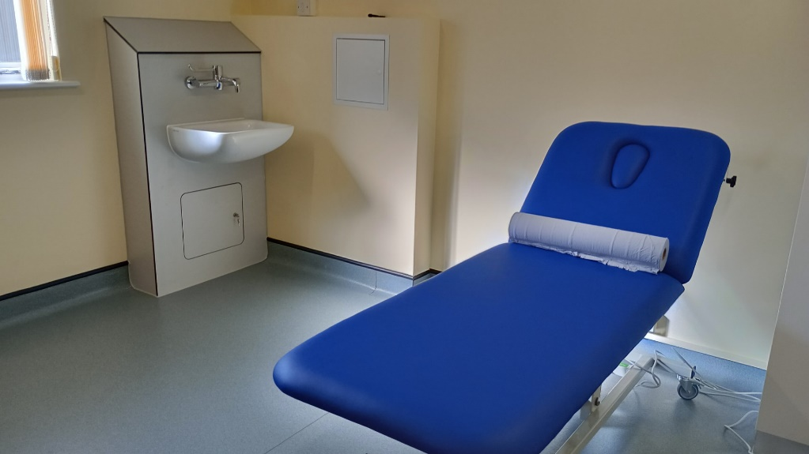

Maldon Knitting Group

The Maldon Knitting Group meets up on the first Tuesday of the month at 10am at Maldon Library, Carmelite House, White Horse Lane, Maldon CM9 5FW. The group do knitting and stitching for charity and work with hospitals, care homes, Farleigh Hospice, Women’s Refuge, Animal Charities and Helen Rollason Cancer Charity. All are welcome to join or just to pop along see the wonderful materials that the group produces.

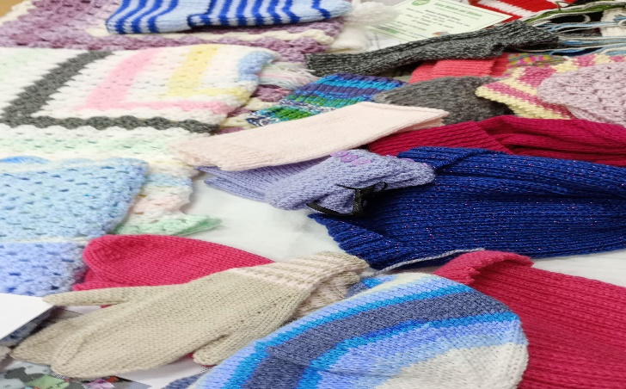

Chronic Disease Annual Recalls

There will be a change in recalls (for example diabetes) for annual reviews to birthday recalls supporting the practice manage demand. The three-monthly blood test requirements for those on certain medications will continue.

Mid Essex 2024 shutdown dates for staff training sessions.

Please be advised that surgeries in Mid Essex will be closed from 12.00pm on
Thursday 21st March 2024
Thursday 25th April 2024

Patients should contact 111 should they have a health concern during this time.

Easter

Please be advised that the surgery will be closed on Friday 29th March 2024 (Good Friday) and Monday 1st April 2024 (Easter Monday), reopening at 8am on Tuesday 2nd April 2024.

